# WORK CONTENT

|  |  |  |  |  |  |  |
| --- | --- | --- | --- | --- | --- | --- |
| **Sl. No.** | **Activity Heads** | **From date- To date** | **Number of Week** | **Total No of Hours** | **Performance Appraisal / Points earned (To be Filled by Coordinators)** | **Remarks** |
| 1 | Helping local schools to achieve good result & enhance their enrolment in Higher/Technical/Vocational Education | 06/11/2024  to 20/12/2024 | 8 | 190 |  |  |
| 2 | Developing and managing efficient garbage disposal system | 06/11/2024  to 27/11/2024 | 4 | 82 |  |  |
| 3 | Contribution to any national level initiative by Government of India – Swachh Bharat | 28/09/2024  to 13/05/2025 | 5 | 83 |  |  |
| 4 | DHEE Hospitals | 22/02/2025  to 08/03/2025 | 2 | 85 |  |  |
| 5 | Tourism Promotion Innovative Approaches | 25/01/2024  to 12/05/2025 | 2 | 90 |  |  |
| **TOTAL ACTIVITY POINTS EARNED** | | | **21** | **530** |  |  |

**ABSTRACT**

The activities undertaken over the designated period aimed at addressing key societal and environmental challenges while fostering community development. A total of 21 weeks and 433 hours were dedicated to these impactful initiatives.

One of the primary activities focused on assisting local schools in improving academic performance and encouraging higher enrollment in technical and vocational education. Spanning eight weeks from November 6, 2024, to December 20, 2024, this initiative involved mentorship, academic support, and career guidance, totaling 190 hours. The efforts contributed to increased student motivation and preparedness for higher education.

Another significant activity revolved around reducing energy consumption, conducted from January 23, 2025, to February 13, 2025, over two weeks. This initiative, which accumulated 102 hours, included awareness programs, implementation of energy-efficient practices, and community engagement to promote sustainable energy use.

As part of the Swachh Bharat campaign, a four-week cleanliness drive was organized from October 11, 2024, to October 31, 2024. With 148 hours dedicated, the campaign focused on promoting hygiene, waste segregation, and community participation in maintaining a clean environment. This initiative significantly contributed to raising public awareness and fostering responsible waste disposal habits.

Efforts to promote rainwater harvesting in urban and rural areas were undertaken from December 4, 2024, to December 24, 2024. The two-week program involved 98 hours of educational workshops, on-ground demonstrations, and collaborations with local authorities to implement rainwater collection systems. The project aimed to address water scarcity and encourage sustainable water management.

Additionally, a two-week initiative from November 6, 2024, to November 27, 2024, was dedicated to developing and managing an efficient garbage disposal system. A total of 130 hours were invested in designing waste collection strategies, raising awareness about proper waste disposal methods, and implementing sustainable waste management solutions within the community.

These activities collectively aimed to enhance education, environmental sustainability, and community well-being. The cumulative efforts contributed significantly to fostering awareness, behavioral changes, and tangible improvements in the targeted areas, demonstrating the impact of structured community engagement and social responsibility initiatives.

# CONTENTS

|  |  |  |
| --- | --- | --- |
| **CHAPTER** | **TITLE** | **PAGE NO.** |
| **1** | **Introduction** | **1-2** |
| **2** | **Details of the Activities**   * 1. Activity 1- Helping local schools to achieve good result & enhance their enrolment in Higher/Technical/Vocational Education   2. Activity 2- Developing and managing efficient garbage disposal system   3. Activity 3- Contribution to Any National Level Initiative by Government of India – Swachh Bharat   4. Activity 4- DHEE Hospitals   5. Activity 5-Tourism Promotion Innovative Approaches. | **3-10** |
| **3** | **Overall Learnings**   * 1. Innovative approaches taken   2. Research done   3. Knowledge and Understanding gained   4. Professional Values and best practices incorporated   5. Areas for further development   6. Challenges and solutions   7. Feedback and continuous improvement | **11-14** |
| **4** | **Documentation of the activities** | **15-19** |
|  | **Conclusion** | **20-21** |
|  | **References** | **22** |

**INTRODUCTION**

* 1. **Activity 1: Helping local schools to achieve good result and enhance their enrolment in Higher/ Technical/Vocational Education**

This activity focused on supporting local schools in improving academic performance and encouraging students to pursue higher, technical, or vocational education. Outreach programs were organized in collaboration with educational institutions to provide guidance on career paths, scholarship opportunities, and entrance procedures for various streams of education.

Special awareness sessions were conducted to educate students and parents about the importance of higher education for long-term career success. Motivational talks by alumni and professionals were arranged to inspire students. Career counselling camps and aptitude tests helped identify individual strengths and align them with suitable higher education options. Additionally, mentorship programs and academic support sessions were introduced to improve performance in board examinations, thereby increasing eligibility and enrolment in advanced education programs.

* 1. **Activity 2: Developing and managing efficient garbage disposal system**

This activity focused on creating a cleaner and healthier environment by implementing an efficient garbage disposal system. Awareness drives were conducted to educate residents on waste segregation, recycling practices, and the importance of reducing plastic use. Dustbins were placed in key areas, and regular collection schedules were established in coordination with local authorities. Volunteers also took part in cleanliness drives and monitored the proper disposal of waste. These efforts helped improve sanitation, reduce health risks, and promote environmental responsibility within the community.

* 1. **Activity 3: Contribution to any national level initiative by government of India**

**- Swachh Bharath**

As part of the larger national effort to create a cleaner and healthier environment through the Swachh Bharat Abhiyan (Clean India Mission), it's crucial to begin with the foundation— schools. The Swachh Bharat Abhiyan encourages everyone to contribute towards making India cleaner, and this responsibility must be instilled from an early age. We visited public roads to collect dry waste and hand over to BBMP. The visit aimed to provide practical knowledge about waste management, the importance of hygiene, and creating a culture of cleanliness among volunteers, aligning with the core objectives of the Swachh Bharat Mission.

* 1. **Activity 4: DHEE Hospitals**

The activity involved learning about food preservation and packaging through a visit to a warehouse handling Kellogg’s and Mars products. We assisted in packaging food items into cartons and transferring them into freezing facilities to maintain product quality. The experience offered insights into industrial food safety practices, cold storage logistics, and the importance of proper handling to prevent spoilage. It also emphasized efficiency, hygiene, and teamwork in large-scale food distribution systems.

* 1. **Activity 5: Tourism Promotion Innovative Approaches.**

The activity focused on promoting tourism through innovative approaches by exploring key destinations in Isha Foundation, including SRS Hills and Pyramid Valley. We captured scenic landscapes and cultural highlights, creating an engaging Instagram reel to showcase the area's attractions. This digital content aims to inspire travel and raise awareness about lesser-known destinations. The initiative combined creativity with social media outreach, demonstrating how modern tools can boost local tourism and community engagement.

# DETAILS OF THE ACTIVITIES

* 1. **Activity 1: Helping local schools to achieve good result and enhance their enrolment in Higher/ Technical/Vocational Education**

## Overview

From 04/06/2022 to 16/06/2024, the activities focused on spreading public awareness about critical health issues, particularly cancer and other non-communicable diseases, through the organization of community marathons and outreach programmes. The initiative aimed to educate the general public on disease prevention, early detection, and the importance of adopting healthy lifestyles. These marathons served as both a symbolic and practical platform to unite people from diverse backgrounds, reinforcing the message that proactive health management can save lives. Informational stalls, expert-led sessions, and health check-up counters were set up at event venues to engage and inform participants.

By encouraging public participation in a high-energy, positive environment, the activity helped reduce stigma, spread credible health information, and cultivate a sense of collective responsibility towards public well-being. Special emphasis was placed on cancer awareness, highlighting early symptoms, preventive screenings, and support systems available for patients and caregivers.

## Use of Technology

* + - * Social Media Campaigns: Platforms like Instagram, Facebook, and WhatsApp were used to promote the marathons, share educational content, and highlight survivor stories to inspire others.
      * QR Codes and Mobile Apps: Participants could scan QR codes to access digital brochures, self-assessment tools, and local healthcare resources.
      * Online Registration & Tracking: A mobile-friendly portal allowed participants to register for the marathon, view route maps, and track their steps and calories burned— tying physical activity directly to the health goals of the event.
      * Video Content: Short videos were produced to explain disease symptoms, lifestyle changes, and the significance of regular health check-ups. These were disseminated before and after the event to reinforce learning.

## Sustainable Development Best Practices

To ensure long-term impact and alignment with global development goals, future initiatives like this can integrate various sustainable practices that benefit both public health and the environment. These may include:

* Eco-friendly Event Planning: Organizers can minimize waste by adopting digital registration, using biodegradable materials for signage and handouts, and setting up reusable water stations to reduce plastic usage.
* Carbon Footprint Reduction: Transportation arrangements can encourage carpooling, cycling, or public transit for participants. Hosting events locally can also reduce travel- related emissions.
* Inclusive Participation: Ensuring that awareness events are accessible to all, including people with disabilities and those from marginalized communities, supports equity and social inclusion.
* Community-Based Partnerships: Collaborating with local NGOs, health departments, and educational institutions can ensure the continuity of awareness efforts and increase community engagement.
* Data and Feedback-Driven Improvements: Collecting feedback and tracking health outcomes over time can help in refining future campaigns and ensuring they remain effective, relevant, and scalable.
* Education for Sustainability: Integrating messages about healthy lifestyles, environmental awareness, and preventive healthcare can create more holistic and lasting change.
  1. **Activity 2: Developing and managing efficient garbage disposal system**

## Overview

The activity focused on contributing to life-saving efforts by organizing and participating in blood donation camps in collaboration with local hospitals and health organizations. These camps aimed to raise awareness about the importance of voluntary blood donation, help maintain stable blood supplies for emergencies, and encourage a culture of regular, responsible donation among the public.

Participants helped in mobilizing donors, supporting camp logistics, and spreading knowledge about who can donate, how often, and the impact each donation can make. Through counseling and interactive sessions, the initiative also worked to reduce fear and misinformation about the donation process.

## Use of Technology

* + - * Online Registrations: Digital forms simplified donor registration, reduced paper usage, and allowed for better planning based on expected turnout.
      * Appointment Scheduling: Donors could book slots in advance to avoid crowding and ensure a smooth flow.
      * Awareness Campaigns: Social media platforms were used to share infographics, testimonials, and real-time updates to attract more donors.
      * Donor Tracking Systems: Donors received SMS/email reminders for future donation eligibility, helping encourage regular participation.
      * Educational Videos: Brief videos explained the process, debunked myths, and highlighted the impact of a single unit of blood—potentially saving up to three lives.

## Sustainable Development Base Practices

Eco-Conscious Planning: Use of digital tools for registration, communication, and feedback can reduce paper waste. Encouraging reusable materials in camp setups can further limit

environmental impact. Mobile Blood Donation Units: Deploying mobile units can reach rural or underprivileged areas, improving access and reducing the need for long travel by donors.

Inclusivity & Health Education: Organizing sessions that not only promote blood donation but also educate the public on nutrition, eligibility, and recovery can increase long-term participation, especially among youth and first-time donors. Community Engagement & Partnerships: Collaborating with local schools, colleges, workplaces, and NGOs can help build a stronger, recurring donor base and foster a culture of shared responsibility.

Feedback & Data Use: Collecting donor feedback and using data to track participation trends can help in better planning, targeting, and scaling future campaigns. Health and SDG Integration: Aligning donation camps with wider health screening and awareness (e.g., for anemia, blood pressure) can create a comprehensive community health model, contributing to SDG 3 (Good Health and Well-Being) and SDG 17 (Partnerships for the Goals).

* 1. **Activity 3: Contribution to any national level initiative of government of India - Swachh Bharat**

## Overview

The activity focused on contributing to the Swachh Bharat Abhiyan (Clean India Mission) through both organized efforts in NSS (National Service Scheme) camps and individual voluntary service. Participants engaged in activities like cleaning public spaces, awareness rallies and waste segregation drives to promote hygiene and civic responsibility in local communities.

Through direct involvement, volunteers addressed issues such as littering, improper waste disposal, and the lack of sanitation awareness. These efforts not only helped improve physical surroundings but also fostered a culture of cleanliness, dignity of labor, and environmental stewardship among youth and community members.

## Use of Technology

* + - * Social Media Engagement: Platforms like Instagram and WhatsApp were used to document activities, share before-and-after transformations, and inspire others to join the mission.
      * Digital Campaigns: Informative posts, reels, and posters were created to spread messages about sanitation, waste segregation, and hygiene habits.
      * Mobile Apps: Government apps like Swachhata App were used to report issues in real-time and monitor progress in cleanliness efforts.
      * Coordination Tools: Tools like Google Sheets, Maps, and Calendar helped organize tasks, allocate areas, and schedule group activities efficiently.
      * Awareness Videos: Short, shareable videos were used in communities and schools to explain the importance of personal and public hygiene in a visual, engaging way.

## Sustainable Development Best Practices

* Waste Segregation at the Source: Implement a system where students and staff separate waste into biodegradable and non-biodegradable categories. Schools should have clearly marked bins for wet, dry, and recyclable waste. This helps reduce landfill waste and allows for better recycling opportunities.
* Composting Organic Waste: Encourage the use of composting for organic waste such as food scraps. Create compost pits or bins in the school to convert biodegradable waste into organic fertilizer for school gardens.
* Encourage Reuse and Recycling: Students can be taught to reuse paper, plastic, and other materials before discarding them. Organize recycling drives and collaborate with local recycling agencies to properly dispose of recyclable materials.
* Promote the Use of Sustainable Products: Encourage the use of eco-friendly products such as cloth bags, reusable containers, and natural cleaning supplies to reduce single- use plastic and harmful chemical products.
* Regular Cleaning of School Premises: Schools should have a regular cleaning schedule and assign specific cleaning tasks to students in a way that encourages teamwork and responsibility. Ensure all high-contact areas (e.g., door handles, tables) are cleaned frequent.
  1. **Activity 4: DHEE Hospitals**

## Overview

This activity provided participants with practical exposure to healthcare logistics and hygiene practices through a collaborative initiative with DHEE Hospitals. Participants observed and assisted in essential non-clinical operations such as managing medical supplies, organizing inventory, and ensuring proper labeling and storage of healthcare materials.

A key aspect of the visit was understanding the importance of temperature-controlled storage for sensitive items like medicines, vaccines, and surgical tools. Participants toured sterile storage areas and learned about protocols to maintain hygiene and prevent contamination. The activity highlighted the significance of effective hospital supply chain management and helped foster a greater appreciation for behind-the-scenes operations critical to patient care.

## Use of Technology

* + - * Automated Packaging Lines: Observations included semi-automated conveyor systems used for sealing and boxing food products with efficiency and consistency.
      * Temperature Monitoring Systems: In the freezer rooms, digital temperature sensors and alert systems ensured that food items remained within safe storage conditions.
      * Inventory Management Software: Barcoding and scanning tools were used to track batch numbers, expiry dates, and location data, allowing for smooth inventory rotation and dispatch.
      * Quality Control Tech: Machines for weight checking, sealing verification, and contamination detection ensured adherence to food safety standards.
      * Cold Chain Logistics: Insights were gained into the technology that enables temperature- controlled transportation, critical for preserving perishable food items during delivery.

## Sustainable Development Best Practices

* + - * Eco-Friendly Packaging Materials: Shift from plastic-based packaging to biodegradable, compostable, or recyclable alternatives to reduce long-term environmental impact.
      * Food Waste Reduction: Implement more robust demand forecasting and inventory tracking to avoid overproduction and wastage of perishable goods.
      * Energy-Efficient Cold Storage: Use solar-powered refrigeration or insulated freezer units to reduce energy consumption in cold storage systems.
      * Consumer Education: Add QR codes on packaging linking to information about storage tips and expiry tracking to help consumers minimize food spoilage.
      * Circular Economy Practices: Encourage returnable packaging or partnerships with recycling facilities to process used materials responsibly.
      * SDG Alignment: These efforts contribute to SDG 2 (Zero Hunger), SDG 12 (Responsible Consumption and Production), and SDG 13 (Climate Action) by promoting food security and reducing resource waste.
  1. **Activity 5 – Tourism Promotion Innovative Approaches**

## Overview

The activity focused on promoting local tourism through innovative and experiential approaches, highlighting lesser-known yet scenic destinations in Karnataka. As part of the initiative, a bike ride was organized to explore beautiful spots such as Isha Foundation, SRS Hills, and Pyramid Valley. These locations, known for their natural beauty and spiritual significance, offered a unique blend of adventure, culture, and wellness tourism.

The journey aimed to document and share the experience of exploring these locations, encouraging others—especially the youth—to engage in eco-conscious and local travel. The activity served as a celebration of nature and cultural heritage, while also supporting small- scale tourism businesses along the way.

## Use of Technology

* + - * Social Media Campaign: Captured experiences were transformed into visually engaging reels, posts, and stories on platforms like Instagram, increasing public interest and visibility.
      * Navigation and Planning Tools: Apps like Google Maps and AllTrails were used for route planning, time estimation, and identifying offbeat spots to explore safely.
      * Digital Content Creation: Smartphone videography, drone shots, and video editing tools helped in creating professional-looking promotional content with minimal resources.
      * Community Engagement: Comments, shares, and location tags helped build a sense of community and curiosity around these destinations, inspiring others to follow similar trails.

## Sustainable Development Best Practices

* + - * Support Local Economies: Encourage tourists to buy from local artisans, eat at local eateries, and use community-based accommodation to benefit the regional economy.
      * Eco-Conscious Travel: Promote minimal-waste travel habits, such as carrying reusable water bottles, reducing plastic usage, and respecting wildlife and cultural norms.
      * Off-Season and Offbeat Travel: Highlight non-peak travel times and lesser-known destinations to reduce overtourism and distribute visitor impact more evenly.
      * Heritage and Environmental Awareness: Use travel content to also educate audiences on local history, biodiversity, and conservation needs.
      * Carbon Offset Efforts: Organize or encourage tree-planting drives or support eco-projects to balance the environmental impact of travel.
      * SDG Alignment: These efforts align with SDG 8 (Decent Work and Economic Growth), SDG 11 (Sustainable Cities and Communities), and SDG 13 (Climate Action) by making tourism a tool for inclusive and responsible development.

**CHAPTER 3**

# OVERALL LEARNINGS

## Innovative Approaches Taken

Each activity incorporated unique and creative strategies to achieve its goals. In the awareness marathon, physical engagement was combined with outreach to create an active and visible method of health education. Tourism promotion adopted a digital-first approach through reel-making and social media storytelling, targeting younger audiences with compelling content. Similarly, food packaging introduced us to industrial-scale innovation such as automated systems and digital quality control**,** showing how technology blends with manual labor for optimal efficiency. Even in the Swachh Bharat initiative, awareness was boosted through street plays, QR-linked posters, and interactive digital content for sanitation promotion.

## Research Done

Prior to each activity, relevant background research was conducted to ensure informed participation. For instance, before the disease awareness marathon, we studied the prevalence and symptoms of common diseases like cancer and diabetes, enabling us to answer public queries credibly. For blood donation, research on blood types, eligibility, and the donation process helped dispel myths among first-time donors. During the Kellogg’s and Mars visit, we read up on supply chain logistics, cold storage technologies**,** and preservation standards**.** Tourism exploration was supported by research into the history, ecological importance, and accessibility of places like SRS Hills and Pyramid Valley, ensuring our content was both accurate and enriching.

## Knowledge and Understanding Gained

* + - In public health, we learned how community-based awareness can tackle misinformation and promote healthier lifestyles.
    - In logistics, we saw first-hand how temperature, packaging, and labelling systems directly impact food safety.
    - In environmental and social responsibility, Swachh Bharat participation deepened our grasp of civic cleanliness, waste segregation, and sustainability.
    - We also gained practical knowledge of tourism trends, audience behavior, and digital storytelling, which are vital in promoting offbeat travel.

Each activity reinforced interdisciplinary awareness — blending science, communication, technology, and social service.

## Professional Values and Best Practices Incorporated

Across all five projects, we consistently emphasized:

* + - * Teamwork: Coordinated planning and execution, especially during events like the awareness marathon and tourism ride.
      * Time management and punctuality: Especially crucial during visits to warehouses and remote tourist sites.
      * Ethical responsibility: Maintaining hygiene in blood donation camps, respecting community spaces during clean-ups, and ensuring truthful messaging online.
      * Health and safety protocols: Following safety measures in food facilities and while engaging in physically active events.
      * Digital professionalism: Creating shareable, accurate, and sensitive content that reflects well on both the cause and ourselves.

## Areas for Further Development

While much was accomplished, we identified key areas where deeper learning is possible:

* + - * More technical understanding of food preservation methods, such as chemical vs. natural preservatives.
      * Improving content engagement for awareness and tourism videos — including scripting, captioning, and editing techniques.
      * Greater outreach impact in campaigns — exploring partnerships with local influencers, healthcare professionals, or government bodies for broader visibility.
      * Advanced planning tools — using project management software or data analysis tools to track impact metrics and improve logistical coordination.

We also recognized the need to better assess the long-term effectiveness of our efforts, especially in behavioural change (Swachh Bharat, awareness programs).

## Challenges and Solutions

During the awareness marathon, one major challenge was sustaining public engagement across the entire route, especially in areas with low footfall or disinterest in health topics. To address this, we used posters, short speeches, and interactive Q&A sessions to capture attention and share key messages effectively. In the blood donation camps, a significant hurdle was convincing hesitant or first-time donors who feared side effects or lacked proper information. We overcame this through clear communication, on-site medical guidance, and reassuring the participants with facts and first-hand accounts from previous donors.

While participating in Swachh Bharat activities, we faced reluctance from some local residents to join or support our clean-up drives, often due to a lack of awareness or motivation. We tackled this by setting visible examples through consistent effort and engaging locals with messages on hygiene, health, and civic pride.

During the food preservation and packaging activity, one challenge was adapting to the fast-paced warehouse environment and maintaining efficiency in tasks like labelling and carton assembly. With guidance from warehouse staff and peer coordination, we quickly adjusted, ensured accuracy, and followed hygiene protocols effectively.

In the tourism promotion initiative, logistical coordination for the bike ride and capturing quality content at each location posed practical difficulties due to time constraints and limited equipment. We planned early, traveled in coordinated groups, and used mobile tools creatively to produce engaging content that promoted the destinations successfully.

## Feedback and Continuous Improvement

After each activity, we conducted informal reviews and group discussions to reflect on what went well and what could improve. Feedback included:

* + - Improve audience interaction during outreach by incorporating more Q&A or live demos.
    - Optimize volunteer roles for smoother task distribution in camps.
    - Make sustainability messaging stronger, especially in tourism and cleanliness drives.
    - Encourage follow-up actions — for example, guiding people on how to register as regular blood donors, or providing links to verified health resources.

Based on these reflections, we refined our future approach — placing more emphasis on engagement quality, measurable impact, and user-driven storytelling.

**CHAPTER 4**

# DOCUMENTATION OF ACTIVITIES

**Spreading awareness about diseases and outreach programmes:**

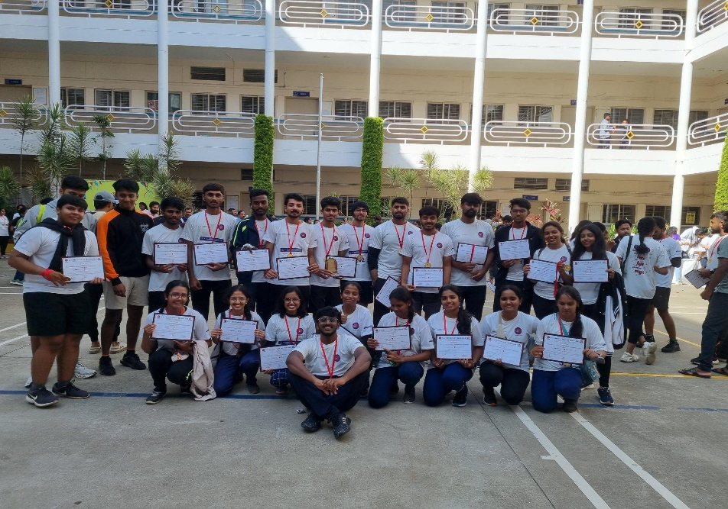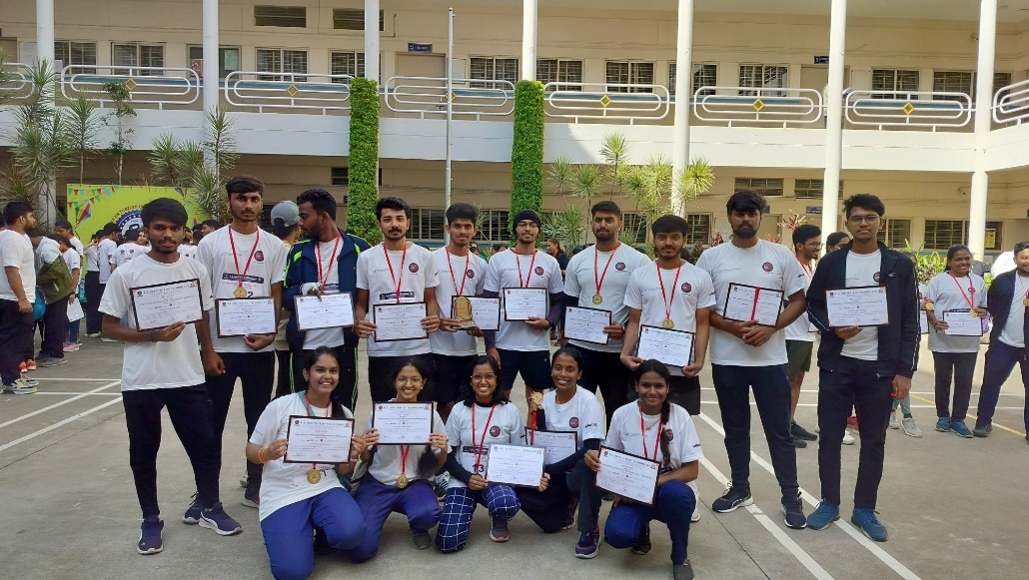

**Helping local schools to achieve good result & enhance their enrolment in Higher/Technical/Vocational Education**

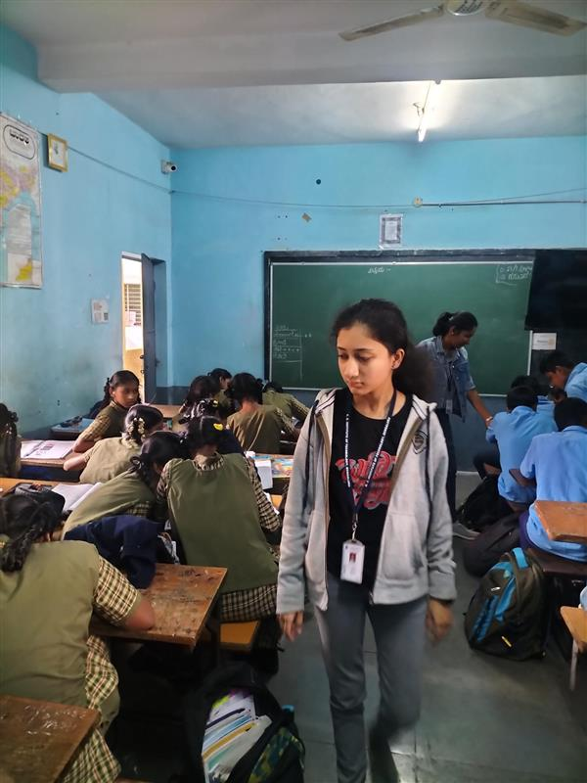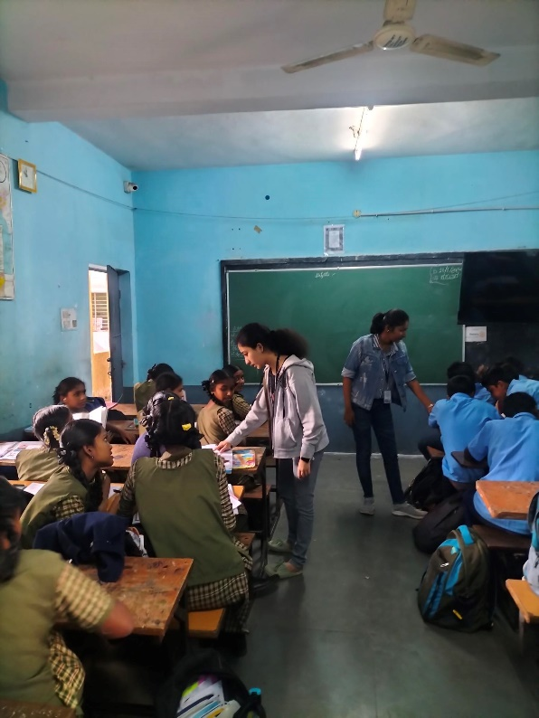

**Contribution to any initiative by Government of India – Swachh Bharat**

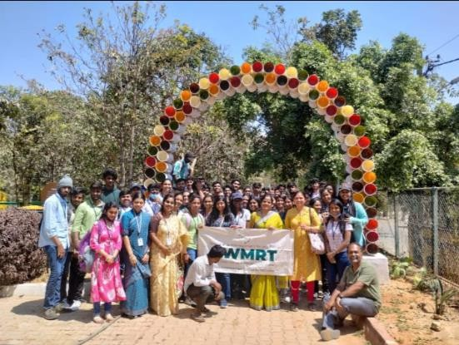

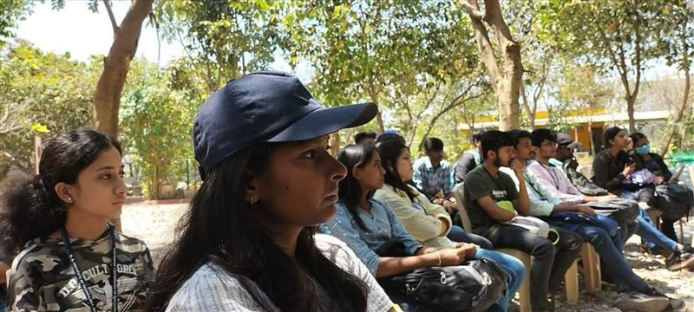

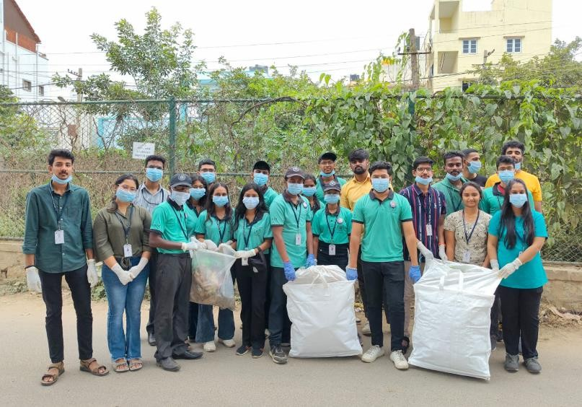

**DHEE Hospitals**

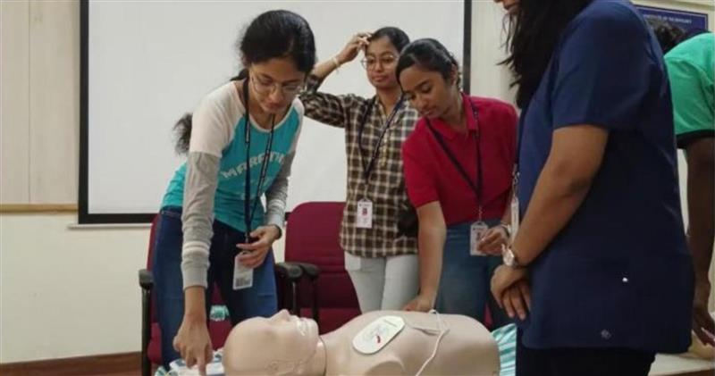

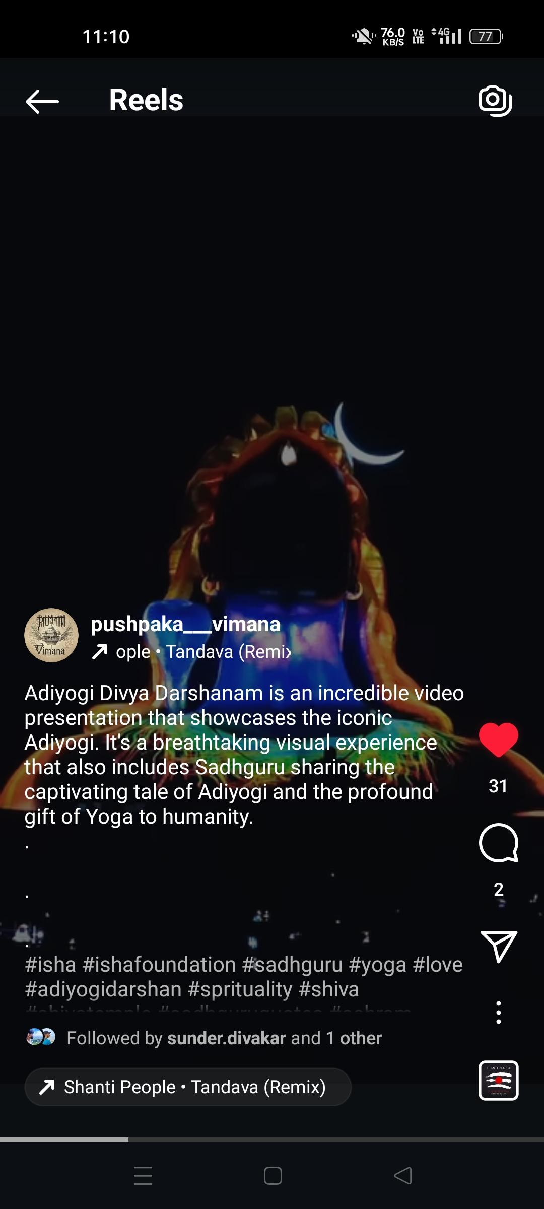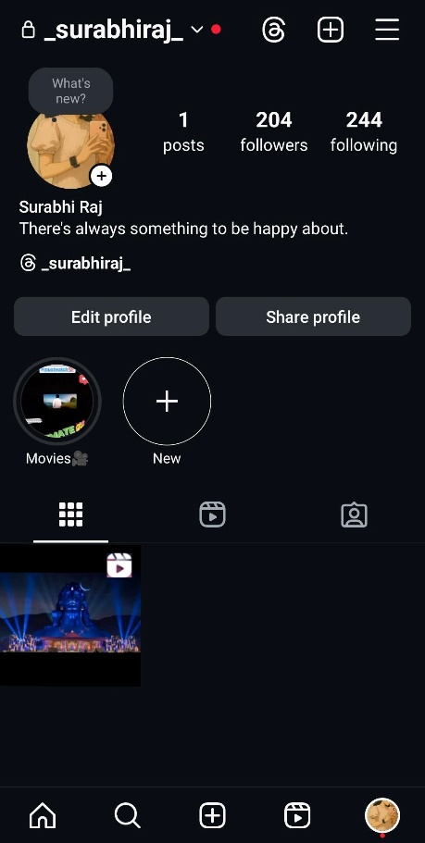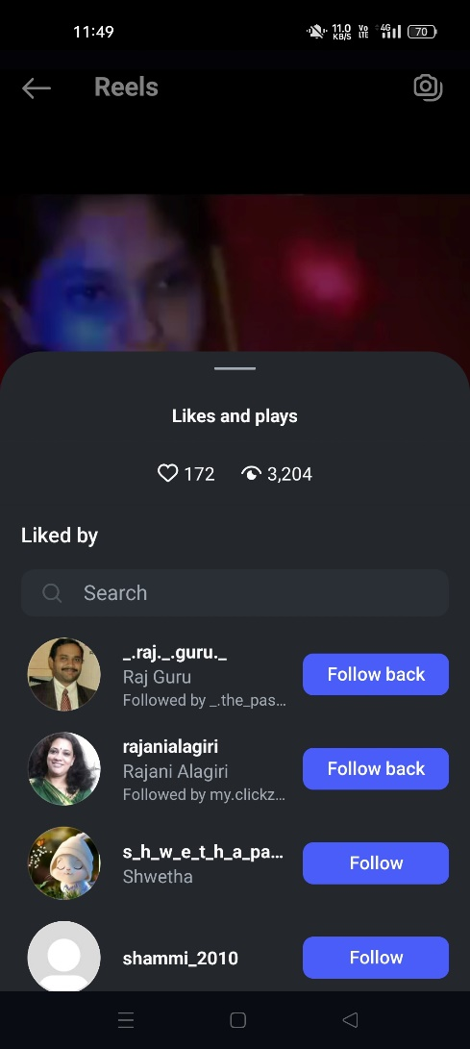**Tourism Promotion Innovative Approaches**

# CONCLUSION

The activities undertaken over the designated period aimed at addressing key societal and environmental challenges while fostering community development. A total of 21 weeks and 433 hours were dedicated to these impactful initiatives.

## Spreading Public Awareness about Diseases and outreach programmes:

The awareness marathons from 04/06/2022 to 15/06/2024 were a powerful initiative that allowed us to connect with the community and deliver vital health information in an accessible way. It strengthened our ability to communicate complex topics clearly and underscored the importance of preventive healthcare outreach. The activity also taught us how physical events like marathons can be effectively used as a platform for large-scale public education.

## Contribution to saving lives by Blood Donation:

Participating in blood donation drives from 08/07/2023 to 13/05/2025 was a deeply meaningful experience, reinforcing the value of empathy and selfless service. It showed us how small actions like donating blood can make a significant difference in saving lives. The experience also helped us learn how to manage on-ground logistics while maintaining a calm and reassuring environment for donors.

## Contribution to any initiative by government of India - Swachh Bharat:

Our involvement in cleanliness campaigns from 28/09/2024 to 13/05/2025 helped us understand the ongoing challenges of public hygiene and civic responsibility. It encouraged us to adopt cleaner habits ourselves and to influence others through consistent, visible efforts.

Working both through NSS and individually reminded us that civic change starts with personal accountability and collective action.

## Food Preservation and Packaging:

Visiting the Kellogg’s and Mars warehouses from 22/02/2025 to 08/03/2025 gave us practical exposure to large-scale food handling and preservation techniques. This experience highlighted the behind-the-scenes work that ensures food safety and sustainability from production to consumption. It also gave us insights into industrial workflows, packaging protocols, and the importance of maintaining a cold chain.

## Tourism Promotion Innovative Approaches:

The tourism initiatives from 25/01/2024 to 12/05/2025 allowed us to creatively combine travel with digital advocacy, showcasing hidden destinations while encouraging eco- conscious exploration. It was a fun yet purposeful way to learn about content creation, local culture, and the role of tourism in community development. The success of our outreach on social media reflected how technology can amplify awareness and support local economies.

# REFERENCES

1. World Health Organization. (2021). *Communicating health risks in outbreaks and emergencies*.
2. World Health Organization. (2023). *Blood safety and availability*.
3. Ministry of Jal Shakti, Government of India. (2022). *Swachh Bharat Mission – Gramin (SBM-G)*
4. Food and Agriculture Organization (FAO). (2021). *Food loss and waste: A food systems approach for policy makers*.
5. United Nations World Tourism Organization (UNWTO). (2023). *Tourism and digital transformation.*